**VR technology Lab IV Report**

Name: Dazhi Li

RUID: 197007456

YouTube Link: <https://www.youtube.com/watch?v=HSN8-P2Qv4Q>

Google Drive Share (project file):

<https://drive.google.com/file/d/1I1-OY7mvwVo9cTLBQABoTHXoWU6KvwQd/view?usp=sharing>

1. Abstract

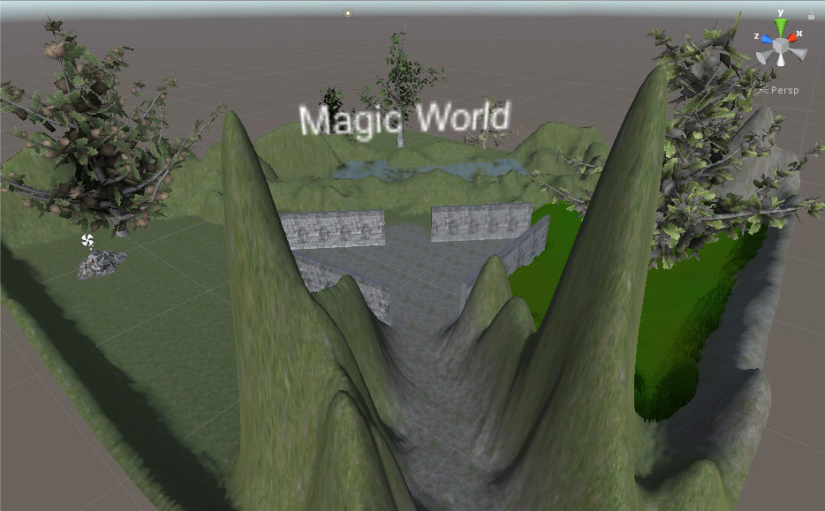

1. Requirements

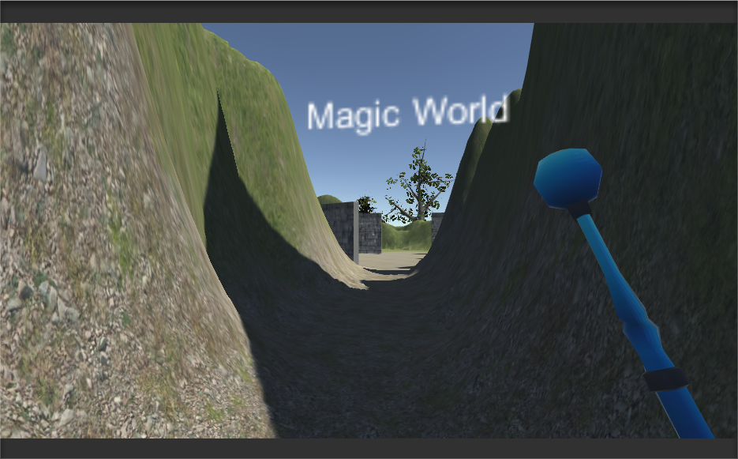

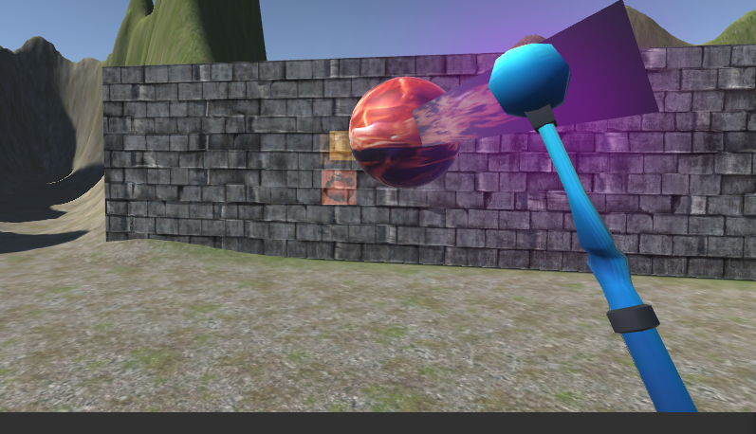

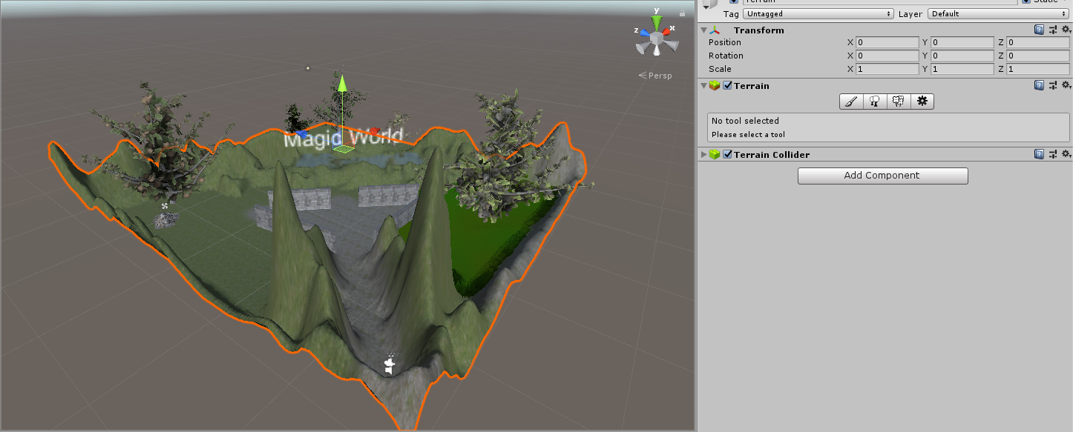

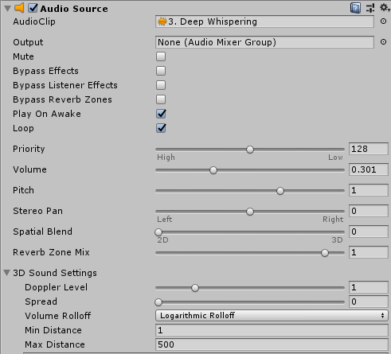

1. [Advanced]

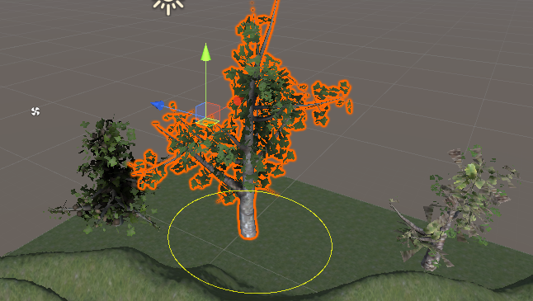

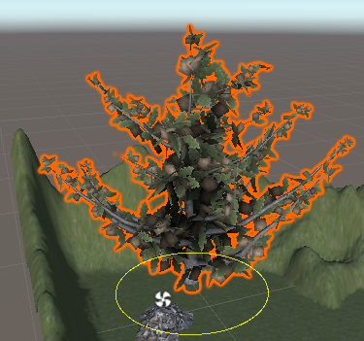

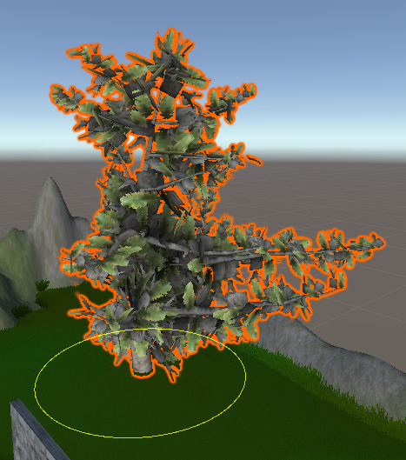

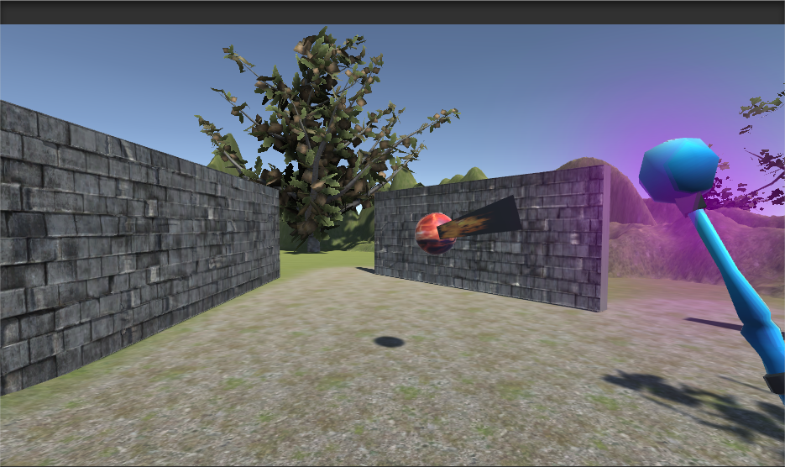

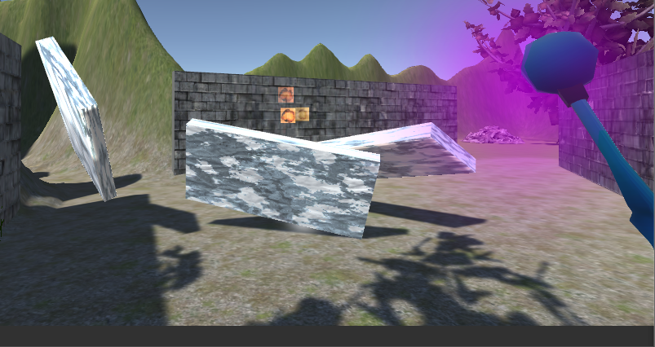

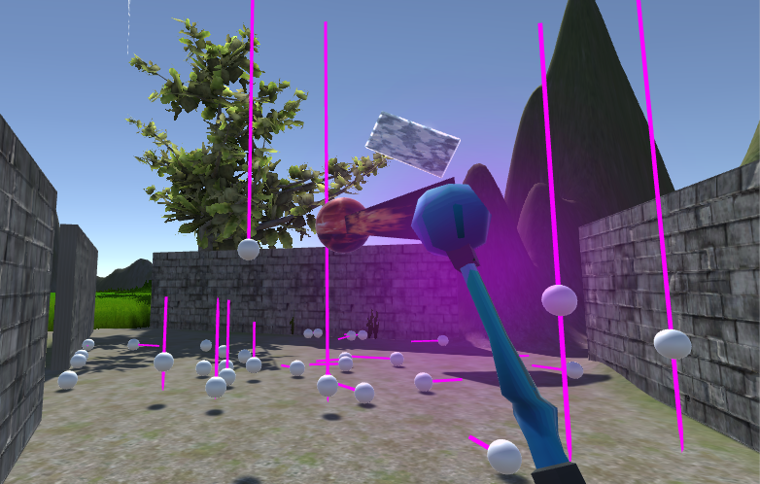

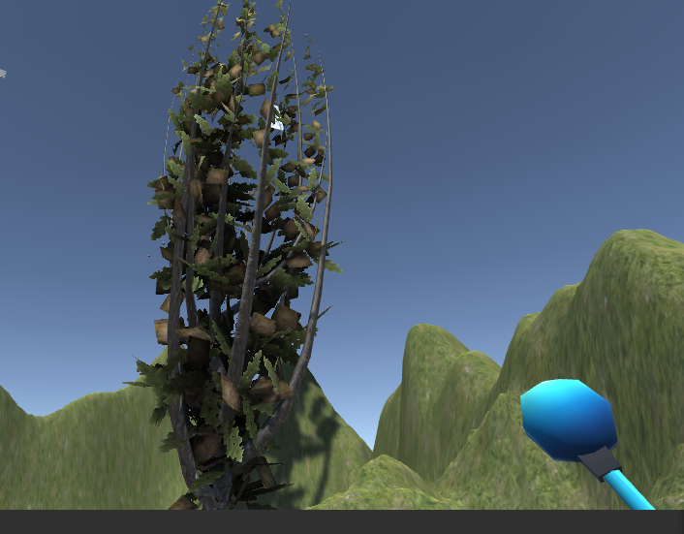

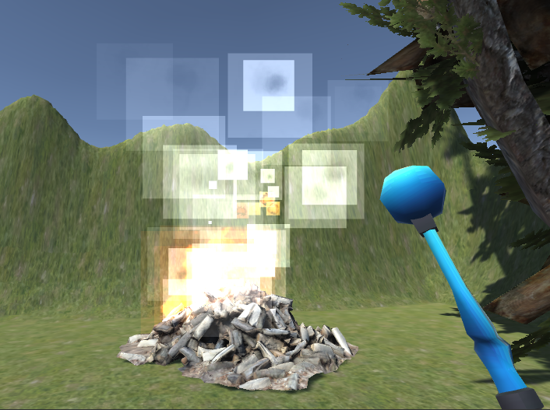

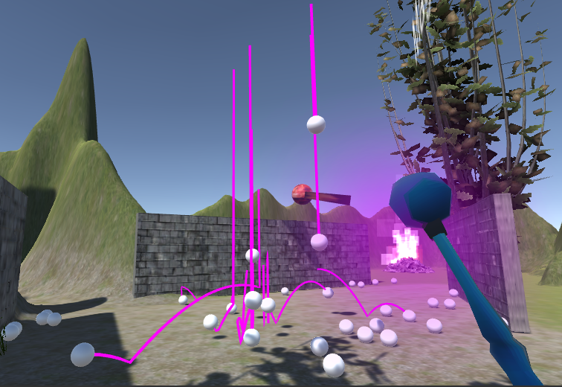

1. Conclusion

From this lab I learnt how to do unity animation and how can we set up a trigger in unity to animate scenes. Also, by using C# scripts will help us improve the interactive ability of unity to users. Finally, physical engine could bring more realistic scene to us.